Part 1

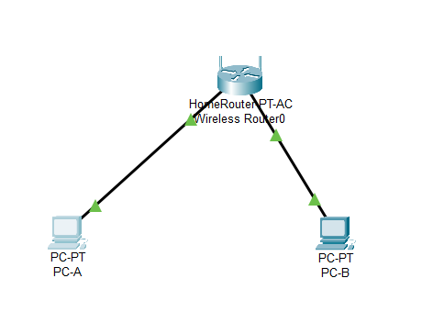

Both PCs were connected to wireless router successfully

Part 2

Typing in the IP address 192.168.1.10 and the subnet mask 255.255.255.0 in PC-A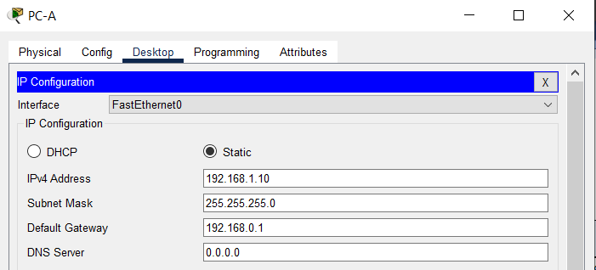

Typing in the IP address 192.168.1.11 and the subnet mask 255.255.255.0 in PC-B 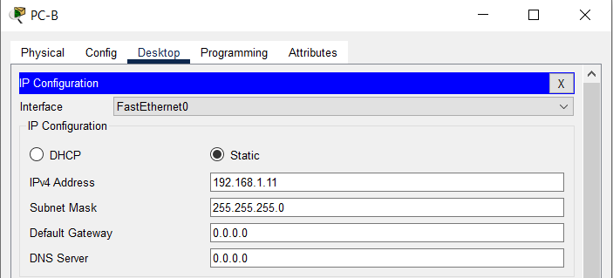

Checking IP and subnet mask in PC-A

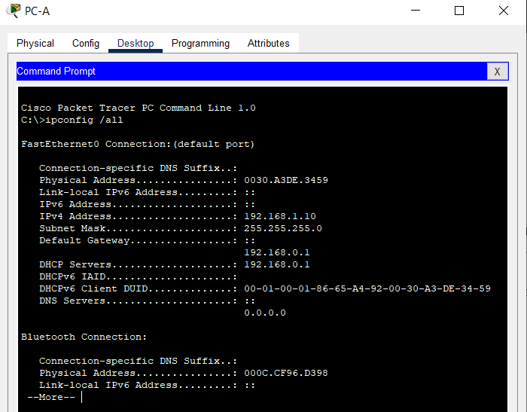

Checking IP and subnet mask in PC-B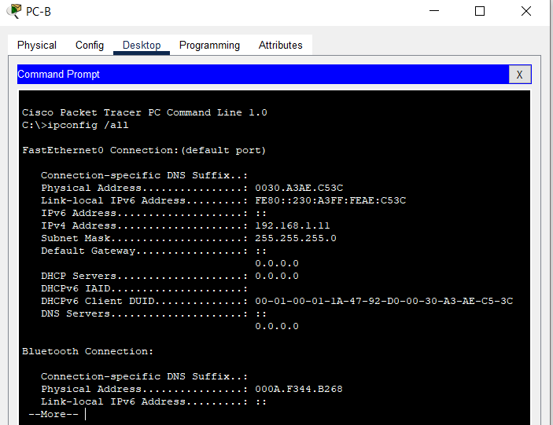

Ping PC-A to PC-B

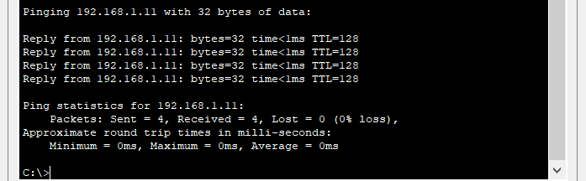

Ping PC-B to PC-A

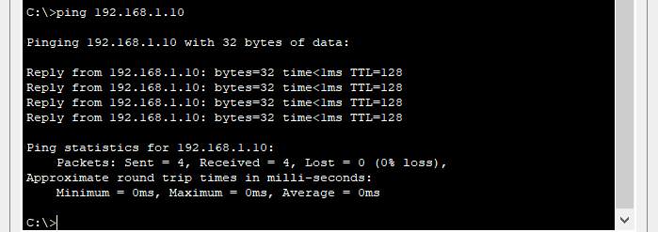

Were the ping results successful?

As you can see in the screenshots ping PC-A to PC-B and ping PC-B to PC-A were successful.